Note: There are four pictures along with their captions below:

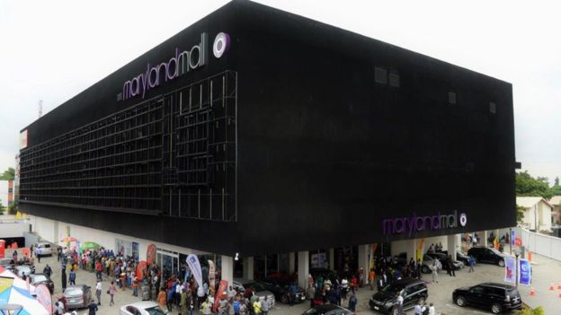Maryland Mall opened in Lagos' Ikeja suburb in June this year. Image copyright PURPLE CAPITAL

Agboola (left) and Onunkwo (right) believe there are opportunities even in a downturn. Image copyright PURPLE CAPITAL

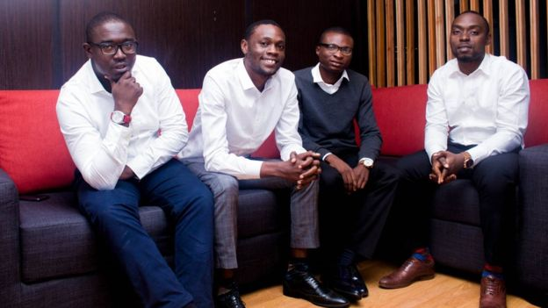The ToLet.com.ng founders started their business with only $400. Image copyright TOLET.COM.NG


A film by Omotayo (left) and Osakwe (right) has just won an award at the Fashion Film Festival Milano. Image copyright AWCA/LAKIN OGUNBANWO

